**202135503 강어진**

**Output from test data set 1(input.txt)**

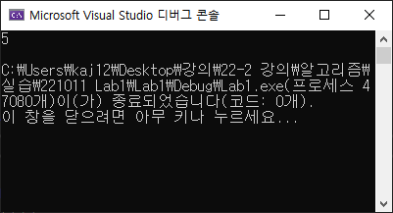

**Output from test data set 2(input2.txt)**

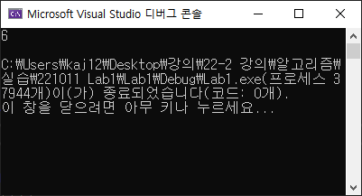

**Output from test data set 3(input3.txt)**

